eCR Now Setup Instructions

Prerequisites
- Docker and Docker Compose installed on your machine.

Building a Custom Docker Image Manually

1. Using Docker Compose with Dockerfile

Steps

1.1 Create a Docker Compose File

Create a file named docker-compose.yml in your project root directory. Here's an example configuration:
services:
postgres:
image: postgres:15
container_name: postgres_container
environment:
POSTGRES_PASSWORD: ecrnow@2024
POSTGRES_DB: ecrnow
networks:
- ecrnow_network
ports:
- "5432:5432"

ecr-now:
build:
context: .
dockerfile: Dockerfile
container_name: ecr-now
depends_on:
- postgres
networks:
- ecrnow_network
volumes:
- D://ecr-now:/config
environment:
- logging.file.name=/config/ecrNow.log
- ersd.file.location=/config/eRSDv2_specification_bundle.json
- schematron.file.location=/config/schematron/CDAR2_IG_PHCASERPT_R2_STU1.1_SCHEMATRON.sch
- xsd.schemas.location=/config/schemas/CDA_SDTC.xsd
- kar.directory=/config/kars
- bsa.output.directory=/config/bsa-output/
- custom-query.directory=/config/custom-queries
- jdbc.url=jdbc:postgresql://postgres_container:5432/ecrNow
- jdbc.username=postgres
- jdbc.password=ecr@2024
- security.key=test123
ports:
- "8081:8080"

networks:
ecrnow_network:
driver: bridge
external: true
name: ecrnow_network

Note: The volumes configuration in Docker Compose maps a directory on the host to a directory inside the container. In the example above, ./config refers to a relative path on the host system. You can adjust the path based on your operating system:
- Windows: Use a path like D://ecr-now/config or C:/Users/yourusername/ecr-now/config.
- Linux: Use a path like /home/yourusername/ecr-now/config or ./config for relative paths.
Environment Variables:
- Verify that the paths and values for the environment variables are correctly set according to your application’s configuration requirements.

1.2 Create a Dockerfile
Create a file named Dockerfile in the project root directory. The Dockerfile defines the image's contents and instructions for building it.
FROM openjdk:17-alpine

RUN apk --no-cache add maven && mvn --version

WORKDIR /java-app

COPY pom.xml .
COPY src ./src

# Package the Spring Boot application, skipping tests
RUN mvn clean install -Dmaven.test.skip=true

# Define the command to run your application
CMD ["java", "-jar", "./target/ecr-now.war"]

1.3 Build and Run the Containers
Navigate to the directory containing the docker-compose.yml file and run the following command:
docker-compose up -d --build
This command will build the Docker image defined in the Dockerfile and start the containers as per the configuration in docker-compose.yml.

1.4: Run PgAdmin Container
1)Run PgAdmin Container:
docker run -d --network ecrnow_network --name pgadmin-container -p 5050:80 -e PGADMIN_DEFAULT_EMAIL=user@domain.com -e PGADMIN_DEFAULT_PASSWORD=postgres -d dpage/pgadmin4
Remember to replace user@domain.com and postgres with your actual email and password.
This command runs PgAdmin in a Docker container (dpage/pgadmin4) on port 5050. It sets the default login credentials (user@domain.com and postgres).
2) Refer this link Connecting PostgreSQL Container using PgAdmin 4

1.5 Run eCR Now UI
Run the eCR Now UI container with the specified environment variable:
docker run -d --network ecrnow_network --restart always -e REACT_APP_ECR_BASE_URL=http://localhost:8081 --name ecrNow-ui -p 3000:3000 drajerhealth/ecr-now:ecr-now-ui-3.1.4

Go to browser and hit http://localhost:3000

1.6: Verify Setup
After running the containers, you can verify the setup by accessing the following:
- eCR Now Backend: http://{{server_ip_address}}:8081
- eCR Now UI: http://{{server_ip_addres}}:3000

2. Using Dockerfile Only

Overview
You can manually build and run Docker images using only a Dockerfile. This is useful for building and deploying single-container applications.

Prerequisites
- Docker installed on your system.

Steps

2.1 Create a Dockerfile

Create a file named Dockerfile in your project root directory. Here’s an example Dockerfile

FROM openjdk:17-alpine

RUN apk --no-cache add maven && mvn --version
WORKDIR /java-app

COPY pom.xml .
COPY src ./src

# Package the Spring Boot application, skipping tests
RUN mvn clean install -Dmaven.test.skip=true

# Define the command to run your application
CMD ["java", "-jar", "./target/ecr-now.war"]

2.2 Build the Docker Image

Navigate to the directory containing the Dockerfile and run the following command:

docker build -t ecr-now-image .

2.3 Create Docker Network
Create a docker network on the name of ecrnow_network, use below command:
docker network create ecrnow_network

2.4 : Run PostgreSQL Container
Run the PostgreSQL container with the specified network and environment variables, use below command:
docker run -d --network ecrnow_network --name postgres_container --restart always -e POSTGRES_PASSWORD=ecrnow@2024 -p 5432:5432 postgres:15
Note: Add password of your choice

2.5: Run PgAdmin Container
1)Run PgAdmin Container:
docker run -d --network ecrnow_network --name pgadmin-container -p 5050:80 -e PGADMIN_DEFAULT_EMAIL=user@domain.com -e PGADMIN_DEFAULT_PASSWORD=postgres -d dpage/pgadmin4
Remember to replace user@domain.com and postgres with your actual email and password.
This command runs PgAdmin in a Docker container (dpage/pgadmin4) on port 5050. It sets the default login credentials (user@domain.com and postgres).
2) Refer this link Connecting PostgreSQL Container using PgAdmin 4

2.6: Create ecr now Database

If the “ ecrnow” database is created using PgAdmin in Step 2.5 , you can skip this step.

Execute the following command to create the ecrnow database inside the PostgreSQL container

docker exec -it postgres_container psql -U postgres -c "CREATE DATABASE ecrnow;"

2.7 Run eCR Now Backend

docker run -d --network ecrnow_network -v D://ecr-now:/config -e logging.file.name=/config/ecrNow.log -e ersd.file.location=/config/eRSDv2_specification_bundle.json -e schematron.file.location=/config/schematron/CDAR2_IG_PHCASERPT_R2_STU1.1_SCHEMATRON.sch -e xsd.schemas.location=/config/schemas/CDA_SDTC.xsd -e kar.directory=/config/kars -e bsa.output.directory=/config/bsa-output/ -e custom-query.directory=/config/custom-queries -e jdbc.url=jdbc:postgresql://postgres_container:5432/ecrnow -e jdbc.username=postgres -e jdbc.password=ecrnow@2024 -e security.key=test123 --link postgres_container:postgres -p 8081:8081 --name ecr-now ecr-now-image

Note: The volumes configuration in Docker Compose maps a directory on the host to a directory inside the container. In the example above, ./config refers to a relative path on the host system. You can adjust the path based on your operating system:
- Windows: Use a path like D://ecr-now/config or C:/Users/yourusername/ecr-now/config.
- Linux: Use a path like /home/yourusername/ecr-now/config or ./config for relative paths.

Environment Variables:
- Verify that the paths and values for the environment variables are correctly set according to your application’s configuration requirements.

2.8 Run eCR Now UI
Run the eCR Now UI container with the specified environment variable:
docker run -d --network ecrnow_network --restart always -e REACT_APP_ECR_BASE_URL=http://localhost:8081 --name ecrNow-ui -p 3000:3000 drajerhealth/ecr-now:ecr-now-ui-3.1.4

Go to browser and hit http://localhost:3000

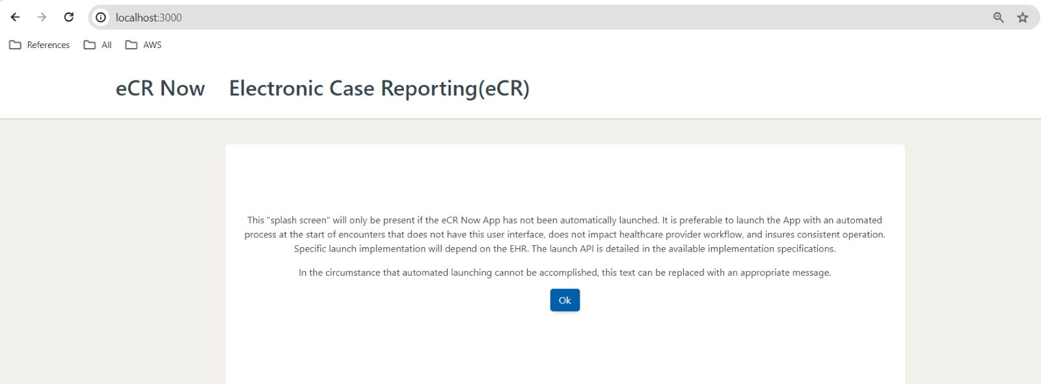

2.9: Verify Setup
After running the containers, you can verify the setup by accessing the following:
- eCR Now Backend: http://{{server_ip_address}}:8081
- eCR Now UI: http://{{server_ip_addres}}:3000

Connecting to Database Container using pgAdmin 4
Log in to pgAdmin 4
Once the container is successfully running (if you encounter any issues, it’s a good idea to check the Docker Desktop app to ensure the container is running), you can access pgAdmin by navigating to localhost:5050 in a web browser of your choice.
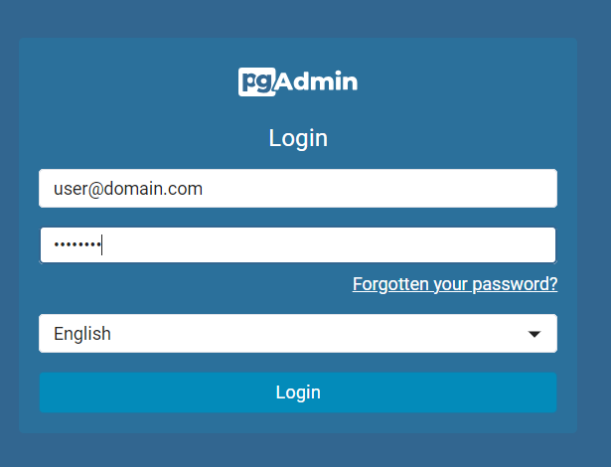
You will then see a login prompt; you will be able to log in with the e-mail address and password that you specified previously when running the pg Admin Docker container
, in our case “user@domain.com” and “postgres”.
Note :-The username and password should be the same as those used when running the pg Admin Docker container.
Connect to Database Container/ Add Server
In the next step, we are going to connect to the database container. For this, you need to click on Add New Server:
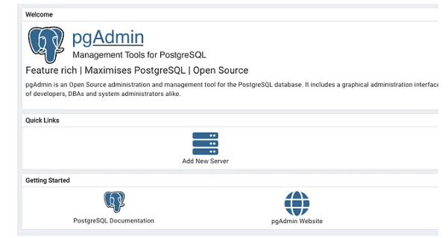
And enter the relevant information to connect to our database, in the Name field we can choose an Alias to refer to our database in Pg Admin:
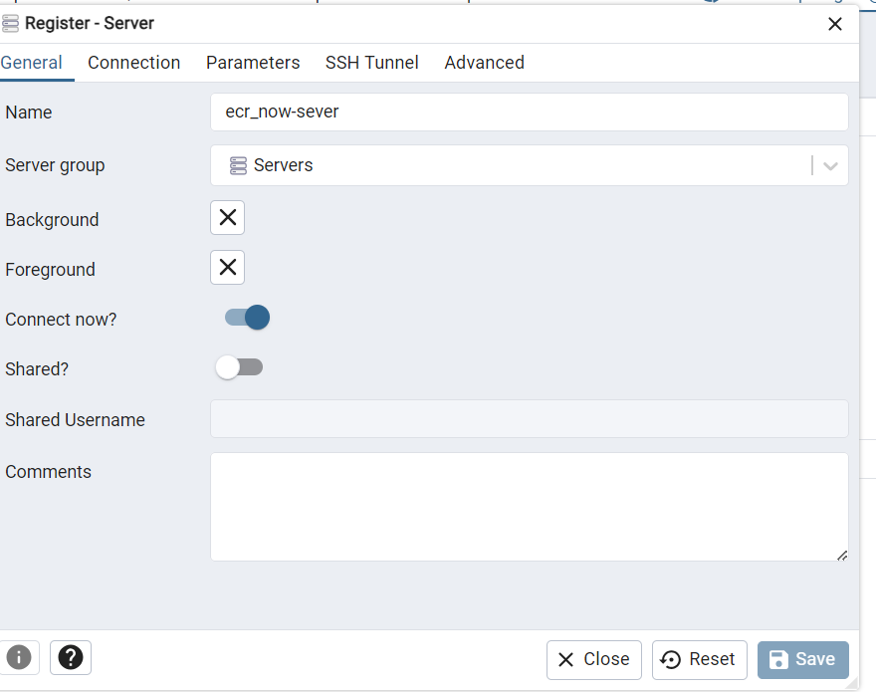

Before we proceed, it’s important to obtain the IP address of the “postgres” container. To find the IP address, you can execute the following command in your terminal (Linux/macOS) or PowerShell (Windows):
docker inspect -f '{{.NetworkSettings.Networks.ecrnow_network.IPAddress}}' postgres_container
In our case, it returned the IP address 172.17.0.3 (this may or may not be true for you). Now we enter all the connection information:
Host name/address: 172.17.0.3 (might be different for you)
or
Host name/address: postgres_container (name of Postgres container)
Port: 5432 (port of postgres container)
Maintenance database: postgres
Username: postgres (or another name if you changed it)
Password: ecrnow@2024 (or whatever password you selected for Postgres container)
Optional: Set save password to true
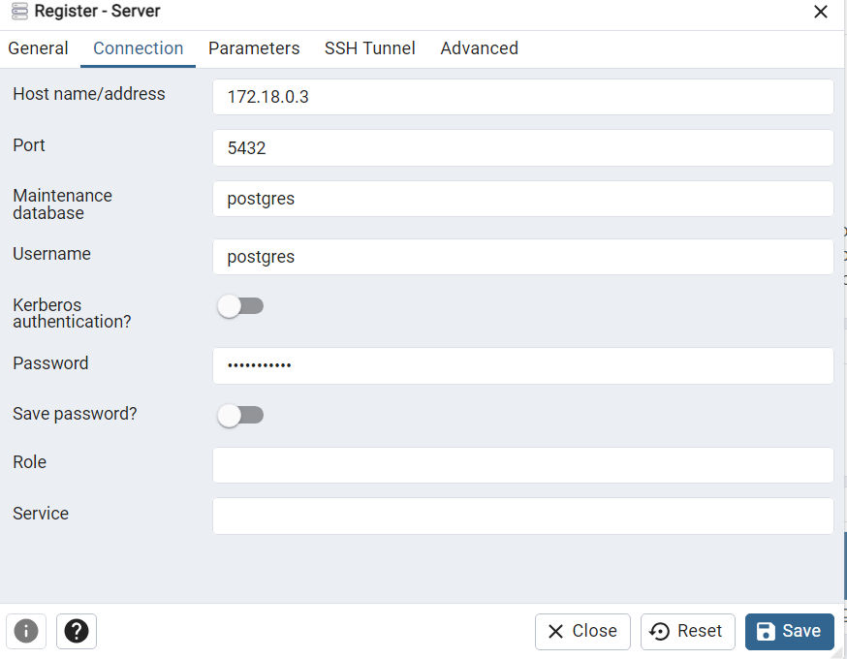

Click Save and you will be able to select your database server from the menu on the left side:
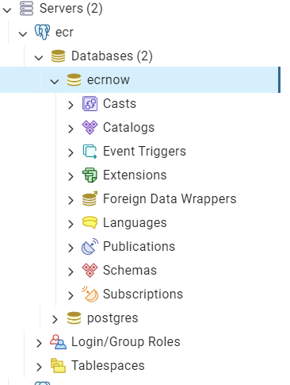
Note:-Create the ecrnow database if database does not exist

Congratulations, now your environment should be up and running. For questions about pgAdmin 4 refer to the documentation:
PgAdmin Docs

